- Visit this link
https://www.morressier.com/call-for-papers/6470b460d239ae0011cad3c6
Create Your Account (If you already have an account, please login and start from step 7)
- Scroll the page to the bottom. At the bottom, submit your email address then select next
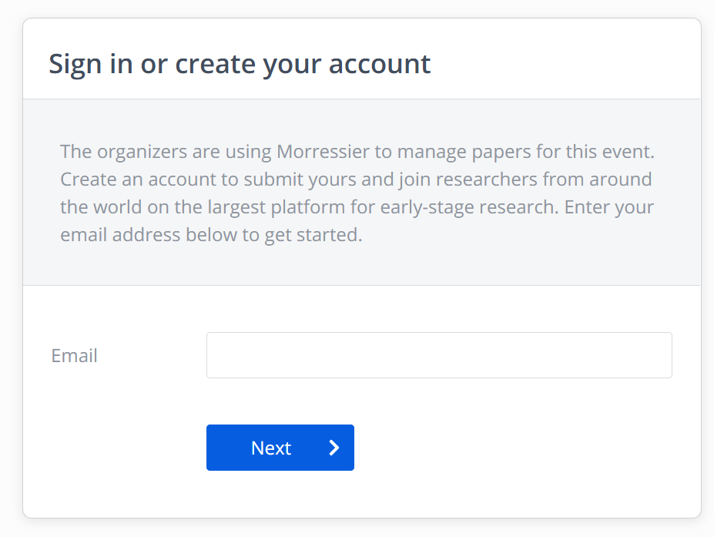
- Open your inbox (e-mail) from Morressier Team and click Confirm Email
- Create account
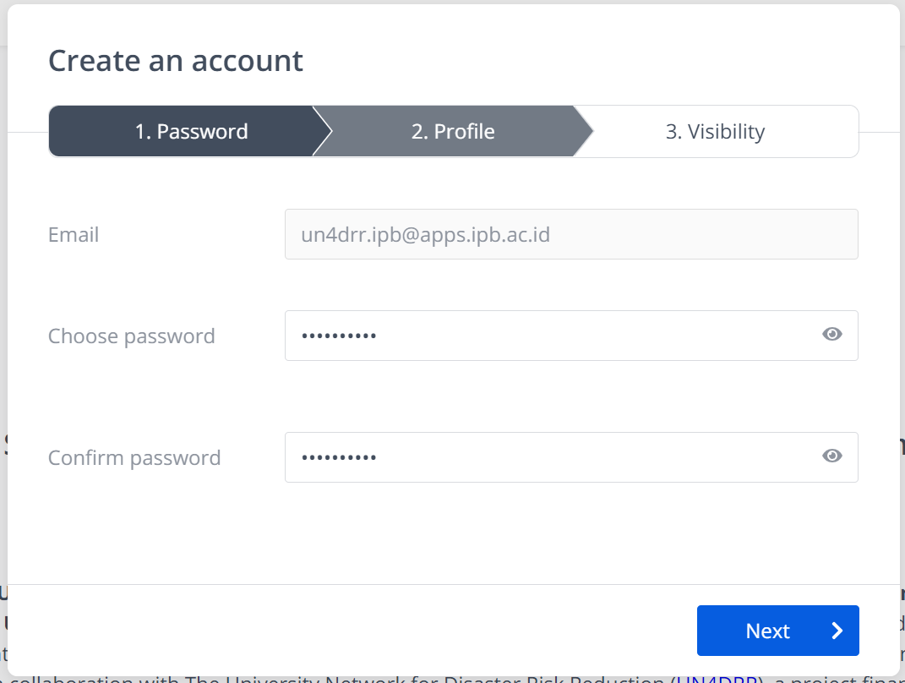

- Fill in your profile
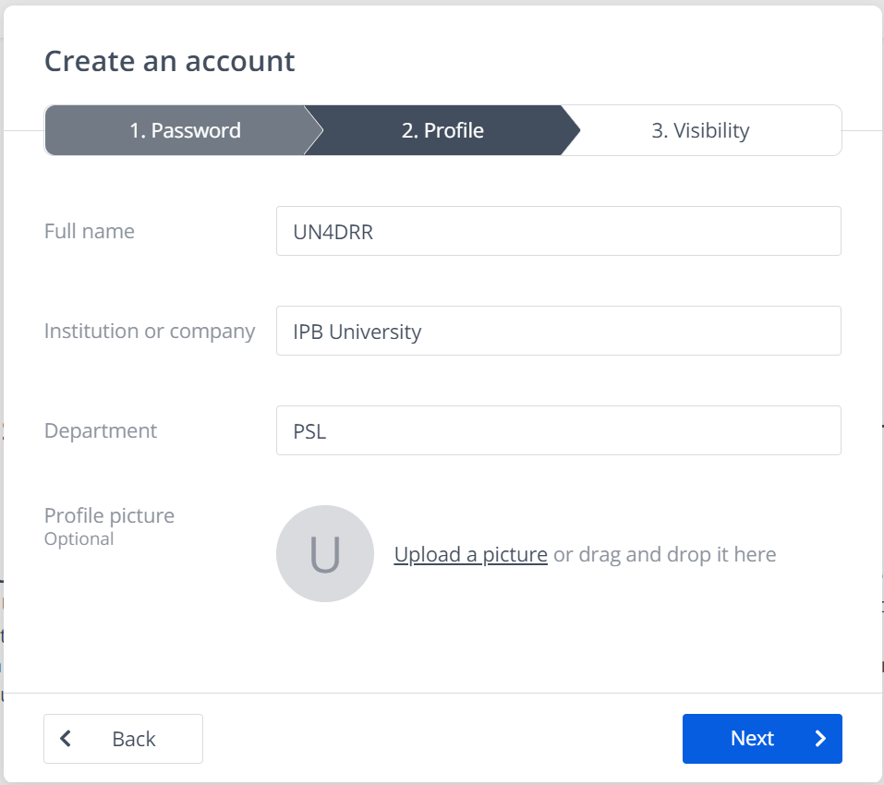
- On visibility, choose public, then click create account
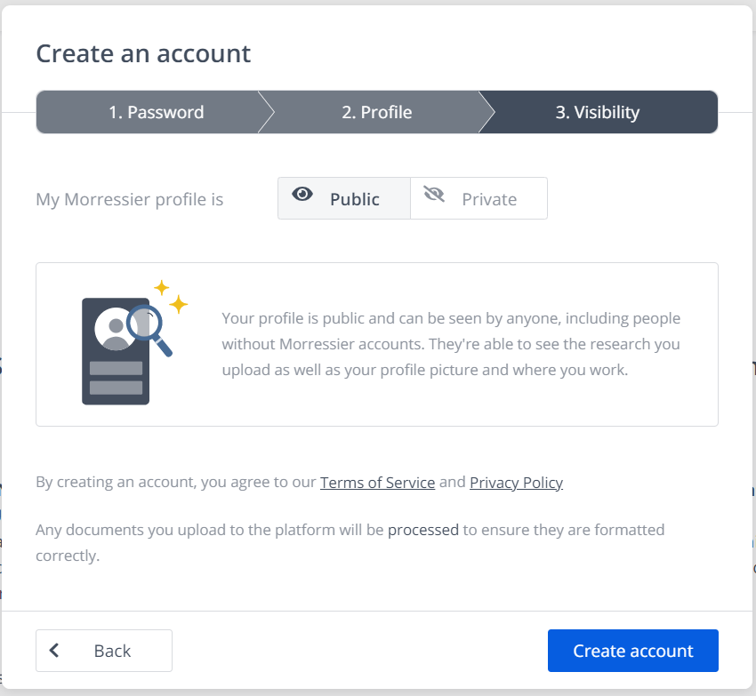

After completing your account, submit your manuscript:
- Write your manuscript title and upload final document (.pdf) that we sent along with this tutorial file, click continue.

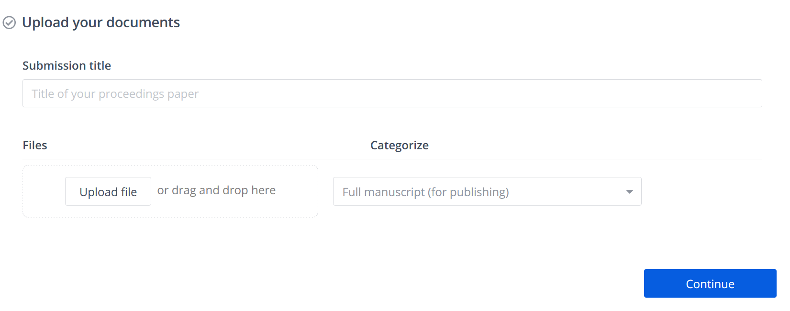
example
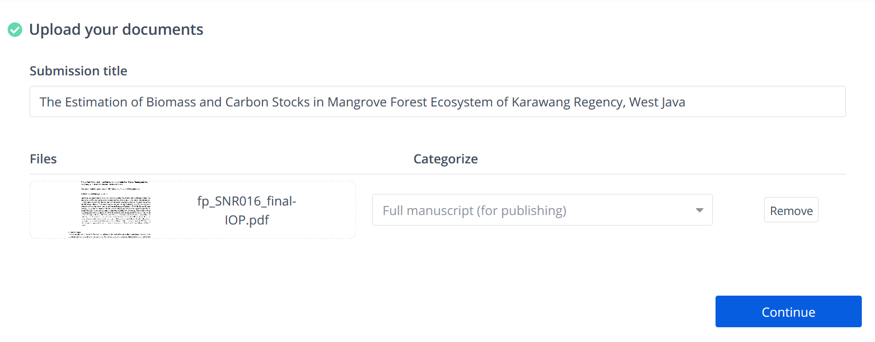
- Choose your manuscript category, leave the keywords empty, click continue.
(if you are still confused about the category, see 3 First Letter of Paper Code on the Letter of Abstract Acceptance that we sent (page 1):
- EMP: Environmental Management and Policy
- EDS: Environmental Dynamics and Ecosystem Services
- GDM: Global Environmental Change and Disaster Management
- NRS: Natural Resources Science

Example: EMP001
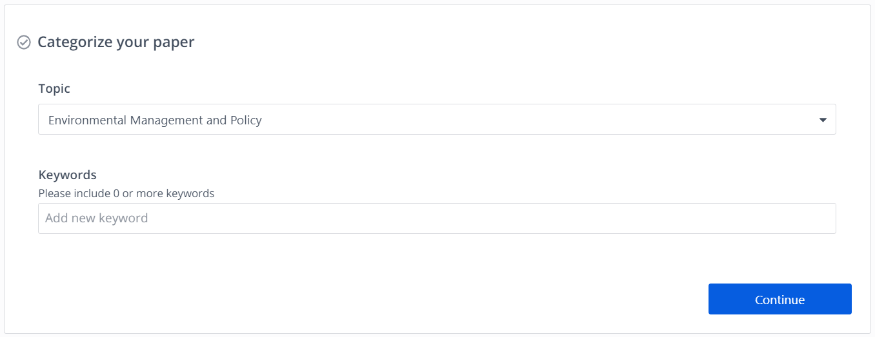

- Copy your revised abstract dan paste it to the abstract column, click continue.
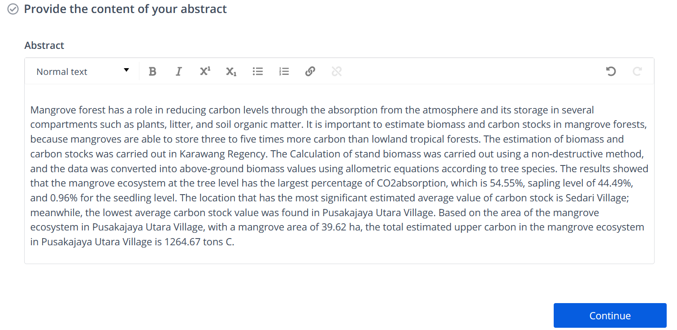
- If you are the 1st author, then check I am the first author of this paper. If you are not the 1st author then write down the identity of the 1st author and the corresponding author (you), click continue
Note: in this column you can only write 1st and corresponding author. Don't worry, the names of all co-authors will still be written on the manuscript that you have uploaded.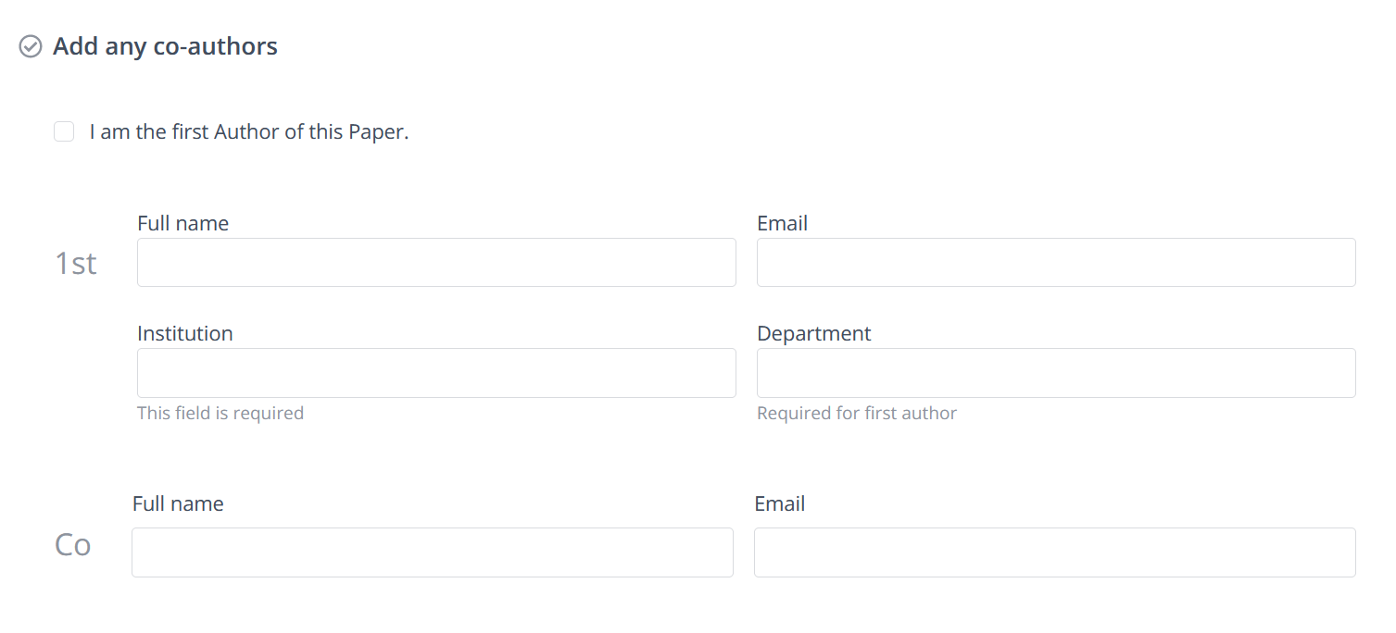
example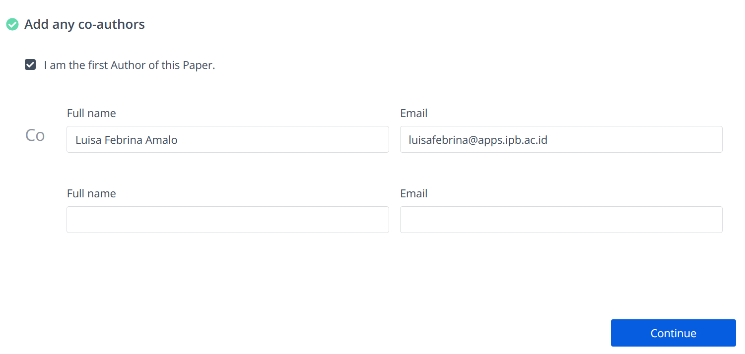

- In this section, choose No, I don’t have a conflict of interest. Click continue.
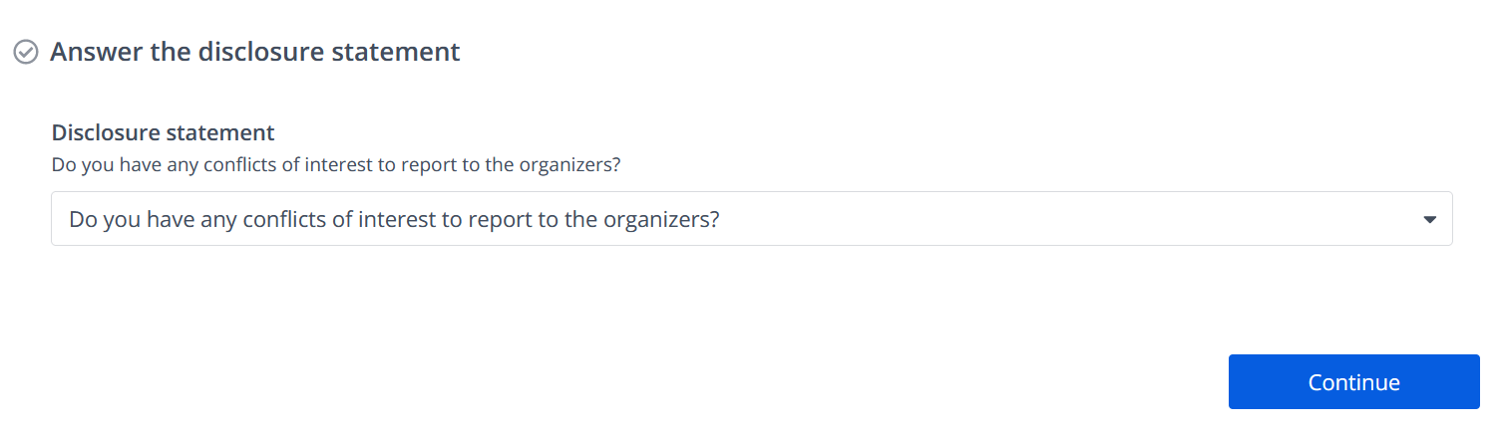
example
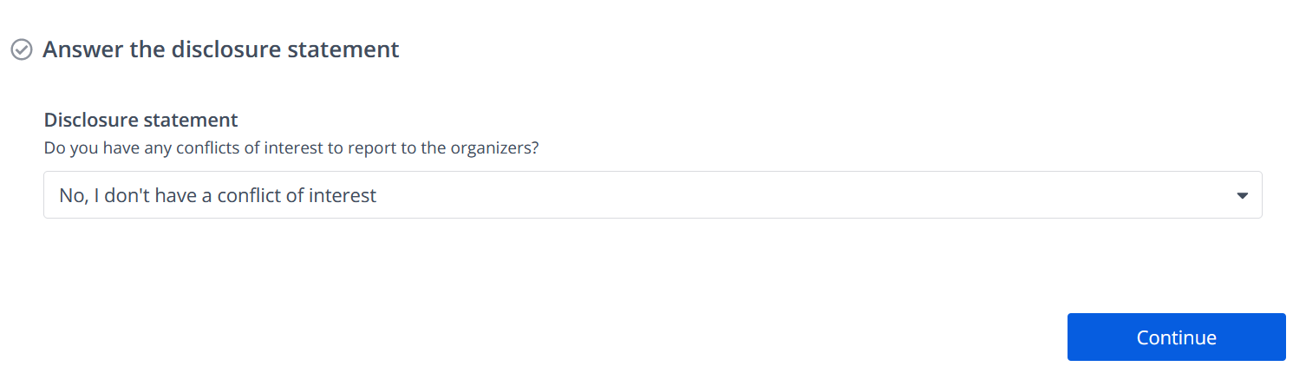
- Check all the selection. Click continue.
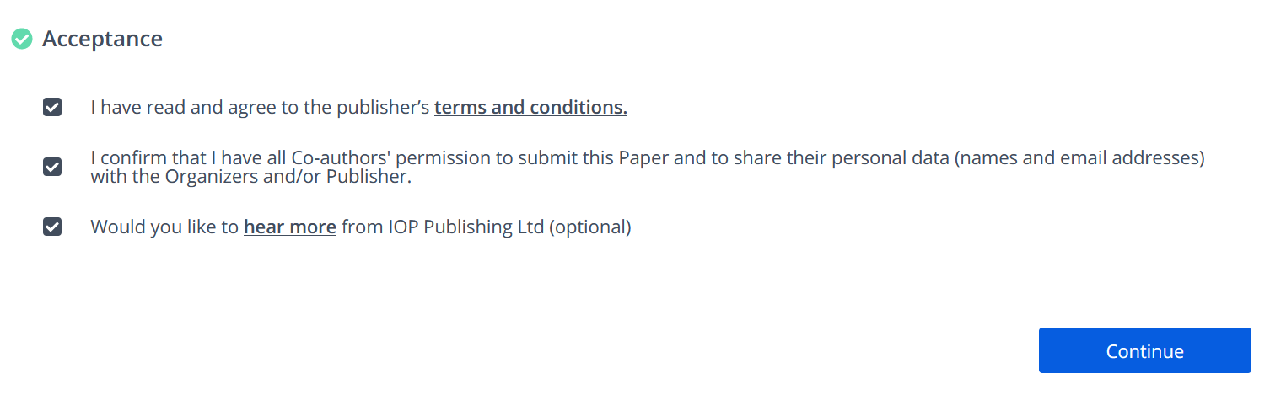
- Click preview and submit.
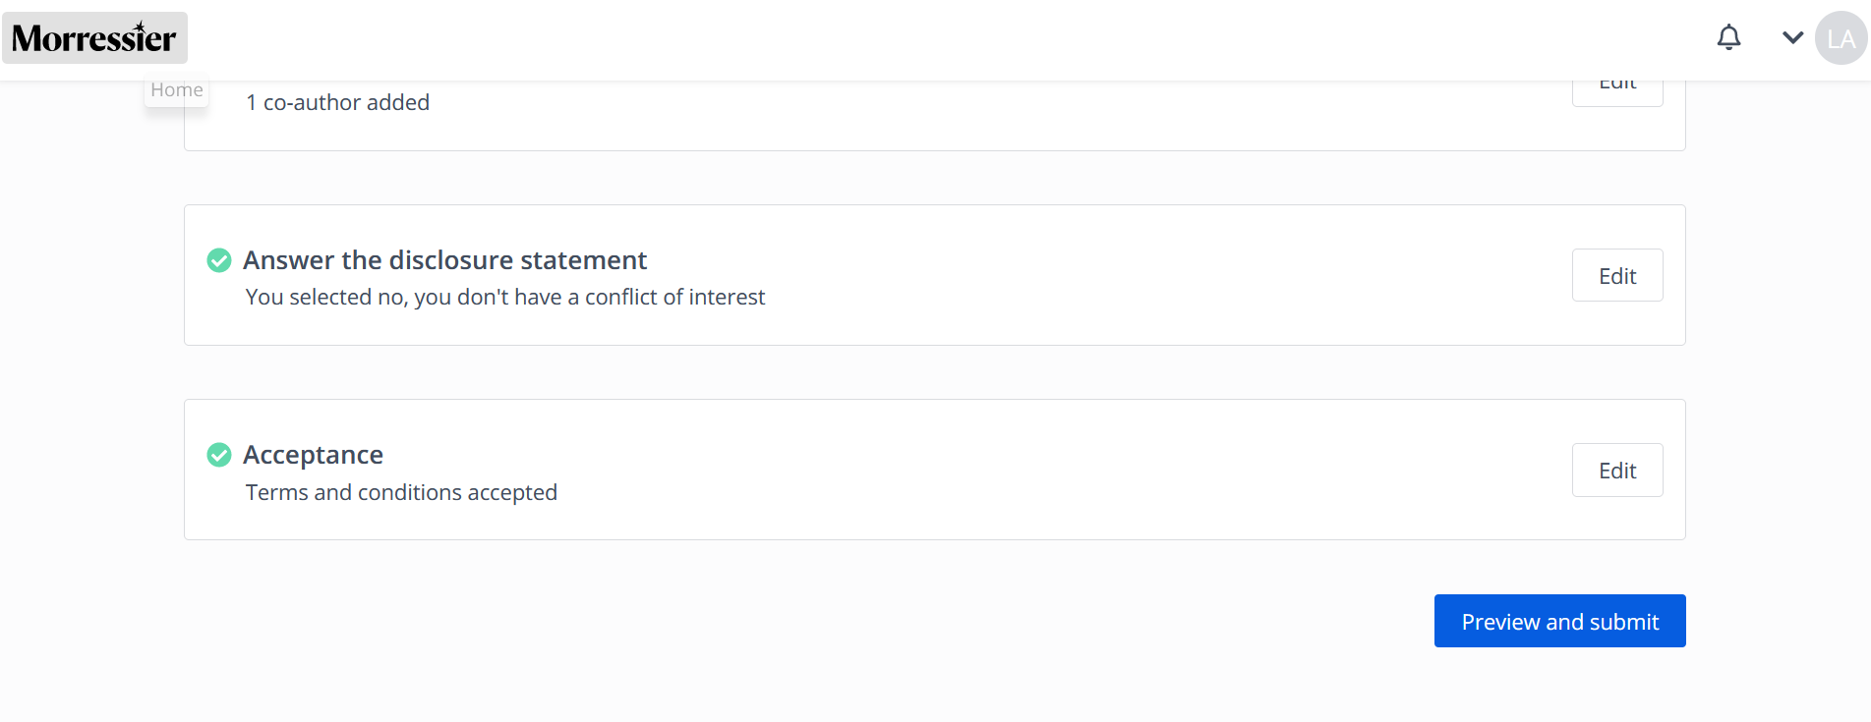
- If you think the preview is okay, click submit.
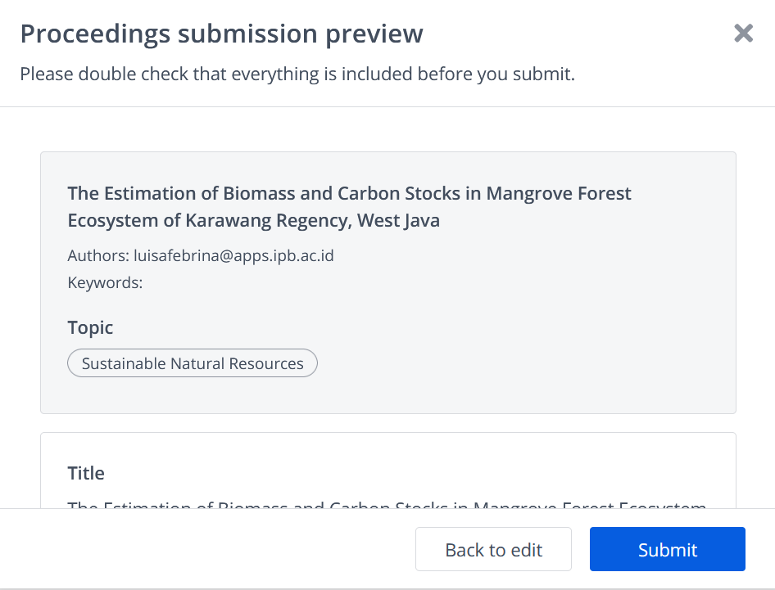

- Click my submissions. If you have another manuscript, click Submit Another Paper and repeat the step from no 7.

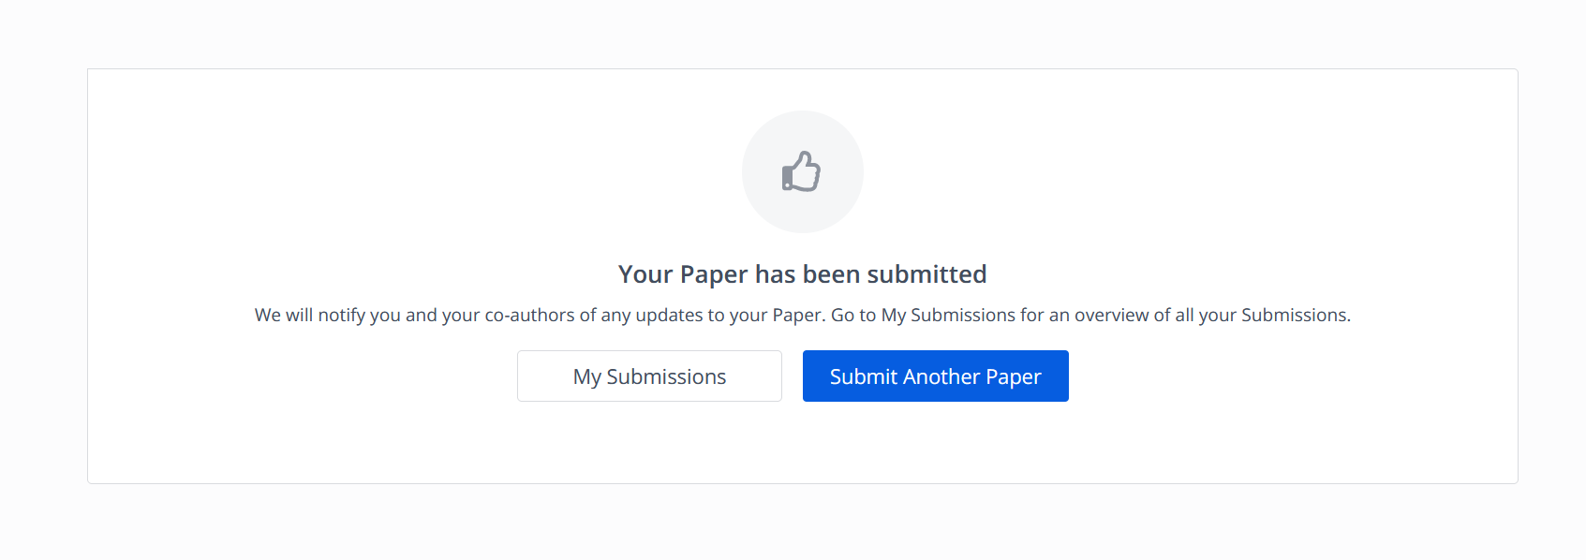
- The preface in my submission. You’ve completed the submission.

